1. Create 2 primary partitions of 3 GB each

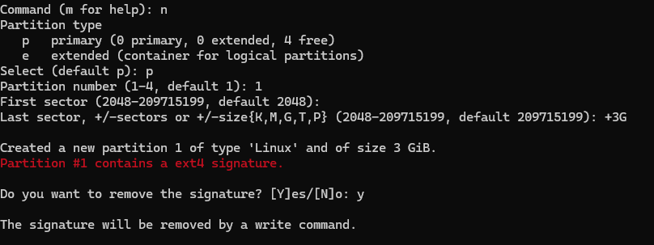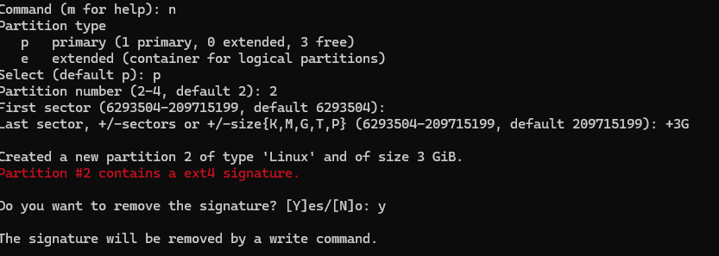

1. A computer screen with white text

   Description automatically generatedCreate 2 logical partitions of 6 GB each
2. A computer screen with white text

   Description automatically generatedFormat all 4 partitions and create ext4 filesystem on that

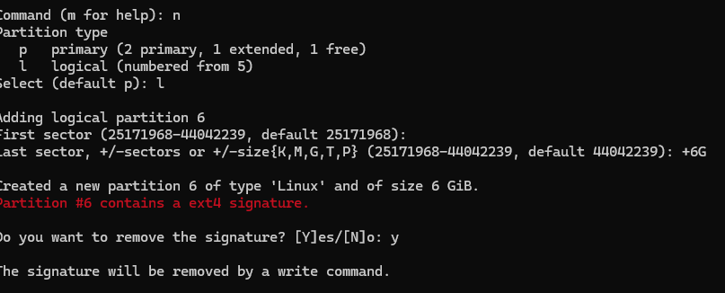

D) Create 4 folders inside root ( / ) folder name it as Data1, Data2, Data3, Data4

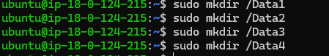

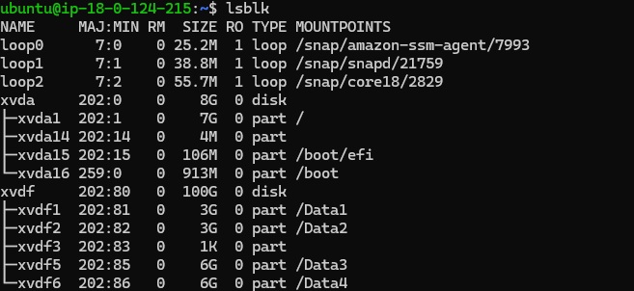 E) Mount all formated partitions on the respective folders

D) Create empty file inside each folders of size 2 GB, 2GB, 4 GB and 4 GB respectively

G) Go inside /Data1  and run  command -  while(true); do sleep 5s; done  , do ctrl-z

h) Check disk utilization of each mount point

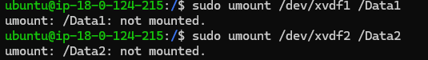  I)  Unmount all partitions /Data1, /Data2, /Data3 and /Data4

